**List of Equations ABE 30800 – Spring 2018**

**Energy Balance**



**General Energy Transport Equation**



**Heat Conduction** (no convection)

* Cartesian Coordinates



* 1D – Heat Flow (x direction)



* Cylindrical Geometry



* 1D – Heat Flow (r-direction – long cylinder)



* Spherical Geometry



* 1D – Heat Flow (r-direction)



**Heat Convection**



**Radiation**







**Heat Transfer in a composite system** (conduction and convection)

* Convection in both sides and conduction through 3 layers – Cartesian Geometry – 1D

 





* Convection in both sides and conduction through 3 layers – Cylindrical Geometry – 1D









* Convection in both sides and conduction through 3 layers – Spherical Geometry – 1D





* Boundary Conditions

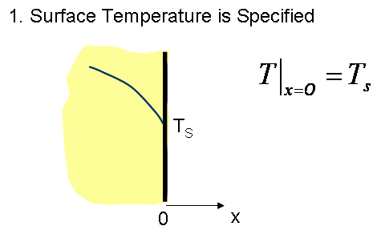

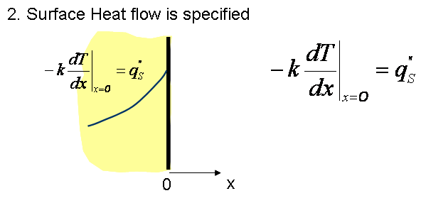

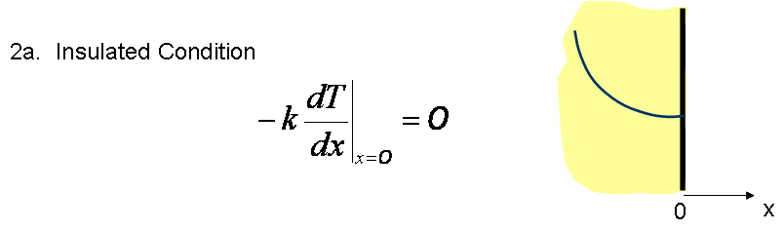



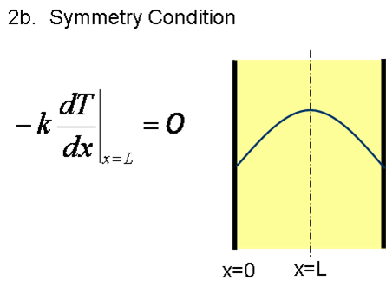

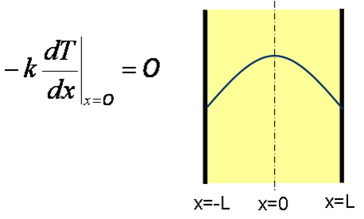or

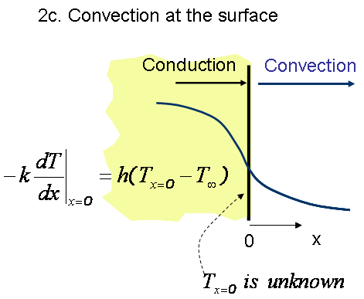

**Steady State Heat Transfer with Heat Generation**

* Cartesian Coordinate – Heat flow in only one direction





* Cylindrical and Spherical Geometry

Equations are specific to the boundary conditions used (see examples given in class)

Steady State Heat Transfer for Extended Surfaces

 



**Conduction Heat Transfer: Unsteady State**

Lumped parameter Analysis





Internal Resistance to Heat Transfer is not negligible

*Using Charts- x is replaced by r and L by R in cylindrical and spherical geometries*



  

L: characteristic length, it depends on the geometry

*Multi-dimensional Problems*





*Analytical Solution (complete) - Slab only*



*Analytical Solution (approximated) - Slab only*





*Transient heat Transfer in a Semi-infinite region*

Constant temperature boundary condition



Convection boundary condition



**Approximated Solution to the Unsteady State Equation (also used for Mass Transfer) for Three Different Geometries without Using Charts.**

These equations can be used for Unsteady State Heat Transfer. In the case of heat transfer problems, concentrations are replaced by Temperatures.

For relative long times, i.e. for Fo > 0.2 the infinite series solution can be approximated by the first term of the series. During lectures, we discussed that equation for slab geometries which is:



However, no equations were given to estimate the temperatures with position and time for **cylindrical and spherical surfaces**. The approach to estimate these temperatures (or concentrations in the second part of this class) was to use specific charts for these geometries. The use of charts sometimes may result cumbersome so a more general approach is used to estimate these temperatures (and concentrations) for Fo > 0.2. For Fo < 0.2 the complete solution (infinite series) should be used.

**The general approach** is summarized in the following equations, e.g. applied to heat transfer:

* For Slab



* For Cylinder



* For Sphere



Where *C1* and  are two parameters that depend on the geometry and are tabulated in the table given in the table below as a function of the Biot number and J0 is the zero Bessel function of the first kind:

|  | **Plane wall** | | **Infinite Cylinder** | | **Sphere** | |
| --- | --- | --- | --- | --- | --- | --- |
| **Bi** |  | ***C1*** |  | ***C1*** |  | ***C1*** |
| 0.01 | 0.098 | 1.0017 | 0.1412 | 1.0025 | 0.1730 | 1.0030 |
| 0.02 | 0.1410 | 1.0033 | 0.1995 | 1.0050 | 0.2445 | 1.0060 |
| 0.03 | 0.1732 | 1.0049 | 0.2439 | 1.0075 | 0.2989 | 1.0090 |
| 0.04 | 0.1987 | 1.0066 | 0.2814 | 1.0099 | 0.3450 | 1.0120 |
| 0.05 | 0.2217 | 1.0082 | 0.3142 | 1.0124 | 0.3582 | 1.0149 |
| 0.06 | 0.2425 | 1.0098 | 0.3438 | 1.0148 | 0.4217 | 1.0179 |
| 0.07 | 0.2615 | 1.0114 | 0.3708 | 1.0173 | 0.4550 | 1.0209 |
| 0.08 | 0.2791 | 1.01130 | 0.3960 | 1.0197 | 0.4860 | 1.0239 |
| 0.09 | 0.2956 | 1.0145 | 0.4195 | 1.0222 | 0.5150 | 1.0268 |
| 0.10 | 0.3111 | 1.0160 | 0.4417 | 1.0246 | 0.5423 | 1.0298 |
| 0.15 | 0.3779 | 1.0327 | 0.5376 | 1.0365 | 0.6608 | 1.0445 |
| 0.20 | 0.4328 | 1.0311 | 0.6170 | 1.0483 | 0.7593 | 1.0592 |
| 0.25 | 0.4801 | 1.0382 | 0.6856 | 1.0598 | 0.8448 | 1.0737 |
| 0.30 | 0.5218 | 1.0450 | 0.7465 | 1.0712 | 0.9208 | 1.0880 |
| 0.40 | 0.5932 | 1.0580 | 0.8516 | 1.0932 | 1.0528 | 1.1164 |
| 0.50 | 0.6533 | 1.0701 | 0.9408 | 1.1143 | 1.1656 | 1.1441 |
| 0.60 | 0.7051 | 1.0814 | 1.0185 | 1.1346 | 1.2644 | 1.1713 |
| 0.70 | 0.7506 | 1.0919 | 1.0873 | 1.1539 | 1.3525 | 1.1978 |
| 0.80 | 0.7910 | 1.1016 | 1.1490 | 1.1725 | 1.4320 | 1.2236 |
| 0.90 | 0.8274 | 1.1107 | 1.2048 | 1.1902 | 1.5044 | 1.2488 |
| 1 | 0.8603 | 1.1191 | 1.2558 | 1.2071 | 1.5708 | 1.2732 |
| 2 | 1.0769 | 1.1795 | 1.5995 | 1.3384 | 2.0288 | 1.4793 |
| 3 | 1.1925 | 1.2102 | 1.7887 | 1.4191 | 2.2889 | 1.6227 |
| 4 | 1.2646 | 1.2287 | 1.9081 | 1.4698 | 2.4556 | 1.7201 |
| 5 | 1.3138 | 1.2402 | 1.9898 | 1.5029 | 2.5704 | 1.7870 |
| 6 | 1.3494 | 1.2479 | 2.0490 | 1.5253 | 2.6537 | 1.8338 |
| 7 | 1.3766 | 1.2532 | 2.0937 | 1.5411 | 2.7165 | 1.8674 |
| 8 | 1.3978 | 1.2570 | 2.1286 | 1.5526 | 2.7654 | 1.8921 |
| 9 | 1.4149 | 1.2598 | 2.1566 | 1.5611 | 2.8044 | 1.9106 |
| 10 | 1.4289 | 1.2620 | 2.1795 | 1.5677 | 2.8363 | 1.9249 |
| 20 | 1.4961 | 1.2699 | 2.2881 | 1.5919 | 2.9857 | 1.9781 |
| 30 | 1.5202 | 1.2717 | 2.3261 | 1.5973 | 3.0372 | 1.9898 |
| 40 | 1.5325 | 1.2723 | 2.3455 | 1.5993 | 3.0632 | 1.9942 |
| 50 | 1.5400 | 1.2727 | 2.3572 | 1.6002 | 3.0788 | 1.9962 |
| 100 | 1.5552 | 1.2731 | 2.3809 | 1.6015 | 3.1102 | 1.9990 |
|  | 1.5707 | 1.2733 | 2.4050 | 1.6018 | 3.1415 | 2.000 |

, *L* is the characteristic length and the Biot number could be the heat or the mass Biot number, *x* is used for a slab and *r* for cylindrical and spherical geometries.

The Bessel Functions of the First Kind arise from the solution of the partial differential equation describing the unsteady state heat conduction model in cylindrical coordinates. The subject has been probably covered in MA 30300. If you need to know more about it, please see <http://mathworld.wolfram.com/BesselFunctionoftheFirstKind.html>

The good news is that complex functions are tabulated and the values of the zero and the first order are given below:

